Please follow the instructions given below to complete the survey for the collection of data on Facebook privacy. DO NOT write your name on the survey anywhere as this is intended to be entirely anonymous.

Respond to questions by checking or marking the box.

1. Age:
   * 18-20
   * 21-23
   * 24-26
   * 27+
2. Grade Level
   * Freshmen
   * Sophomore
   * Junior
   * Senior
3. Do you have a Facebook account?
   * Yes
   * No

**If you do not have a Facebook account, please answer questions A-C, You DO NOT need to answer any further questions on this survey. If you do have a Facebook account continue to question 4 without answering questions A-C**

1. Have you ever had a Facebook account in the past? (If you answer no, there is no further questions for you to answer)
   * Yes
   * No
2. If you answered Yes to question A, how long ago did you delete the Facebook account?
   * Less than 6 months
   * 6 months to 1 year
   * Over a year ago
3. What made you decide to delete your Facebook account?
   * Lack of interest
   * To many annoying notifications/emails
   * To better protect your privacy
   * Too much “drama”
   * Other: ________________
4. What platform do you access Facebook from the most? (Tablets are to be considered a mobile device)
   * Android Mobile Device
   * Apple Mobile Device
   * Other Mobile Device
   * Mac
   * PC
   * Other
5. How often do you go on Facebook to view friend’s activity and content?
   * Once a week
   * Three times a week
   * Once daily
   * 2 - 4 times a day
   * 5 - 10 times a day
   * 10 or more times a day
6. When you access Facebook to view friend’s content and activity, how long do you typically view it before logging off or closing the application?
   * Less than 2 minutes
   * Between 2 and 5 minutes
   * Between 5 and 10 minutes
   * Longer than 10 minutes
7. When was the last time you viewed you Facebook privacy settings?
   * Less than a week ago
   * 1 - 2 weeks ago
   * 2 - 4 weeks ago
   * 1+ Month ago
   * 6+ Months ago
   * 1 year ago or more

The following instructions will show you how to access your Facebook privacy settings. Please follow these steps and respond to the questions based on what your current settings are. If you decide to make changes while completing the survey, please indicate changes made in the space provided.

Step 1:

Go to [www.facebook.com](http://www.facebook.com)

Step 2:

Login to your Facebook account using your username and password

Step 3:

Across the top of the screen you will see the Facebook “hot bar” (see below image)



All the way to the right on that hot bar you will see the downward facing triangle



Click the triangle and choose “settings”

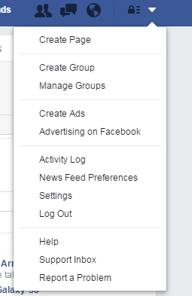

This takes you to you “General Account Settings”. On the left you will see some other tabs as shown in the figure below.

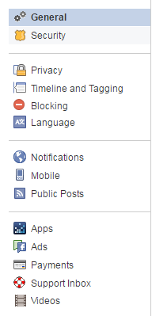

Select the “Privacy” tab, which will bring you to a screen similar to the one shown below.

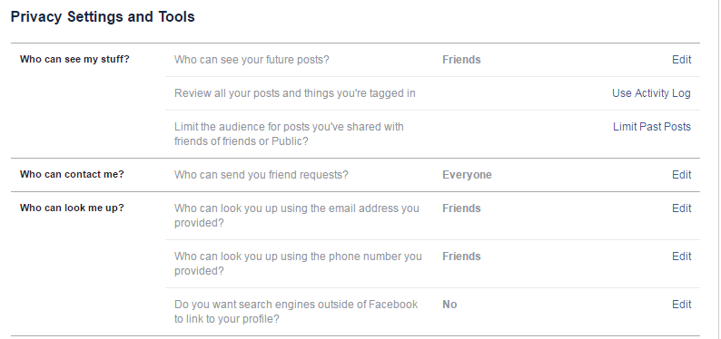

Step 4:

Respond to the following questions by recording what is displayed in the 2nd column of this screen.

1. Who can see your future posts?
   * Public
   * Friends
   * Only Me
   * Custom

**If you changed this setting what is your new chosen setting?**

* Public
* Friends
* Only Me
* Custom

1. Who can send you friend requests?
   * Everyone
   * Friends of Friends

**If you changed this setting what is your new chosen setting?**

* Everyone
* Friends of Friends

1. Who can look you up using the email address you provided?
   * Everyone
   * Friends of Friends
   * Friends

**If you changed this setting what is your new chosen setting?**

* Everyone
* Friends of Friends
* Friends

1. Who can look you up using the phone number you provided?
   * Everyone
   * Friends of Friends
   * Friends

**If you changed this setting what is your new chosen setting?**

* Everyone
* Friends of Friends
* Friends

1. Do you want search engines outside of Facebook to link your profile?
   * Yes
   * No

**If you changed this setting what is your new chosen setting?**

* Yes
* No

Step 5:

From the tabs on the left (shown below) select “Timeline and Tagging”



Step 6:

You should now see a screen similar to the one below. 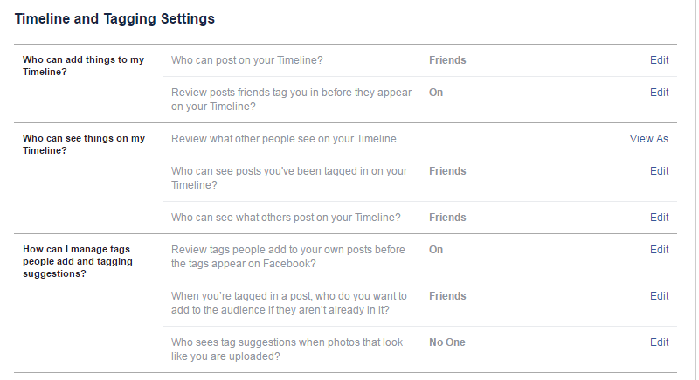

Step 7:

Respond to the following questions using the information displayed in the 2nd column.

1. Who can post on your Timeline?
   * Friends
   * Only Me

**If you changed this setting what is your new chosen setting?**

* Friends
* Only Me

1. Review posts friends tag you in before they appear on your Timeline?
   * On
   * Off

**If you changed this setting what is your new chosen setting?**

* On
* Off

1. Who can see posts you’ve been tagged in on your Timeline?
   * Everyone
   * Friends of Friends
   * Friends
   * Only Me
   * Custom

**If you changed this setting what is your new chosen setting?**

* Everyone
* Friends of Friends
* Friends
* Only Me
* Custom

1. Who can see what others post on your Timeline?
   * Everyone
   * Friends of Friends
   * Friends
   * Only Me
   * Custom

**If you changed this setting what is your new chosen setting?**

* Everyone
* Friends of Friends
* Friends
* Only Me
* Custom

1. Review tags people add to your own posts before the tags appear on Facebook?
   * On
   * Off

**If you changed this setting what is your new chosen setting?**

* On
* Off

1. When you’re tagged in a post, who do you want to add to the audience if they aren’t already in it?
   * Friends
   * Only Me
   * Custom

**If you changed this setting what is your new chosen setting?**

* Friends
* Only Me
* Custom

1. Who sees tag suggestions when photos that look like you are uploaded?
   * Friends
   * No One

**If you changed this setting what is your new chosen setting?**

* Friends
* No One

**After responding to the questions above and viewing your Facebook settings please respond to the last questions below**

1. Was it easy to understand what each of the Facebook settings options actually did?
   * Very easy to understand
   * Relatively understandable
   * Slightly confusing
   * Very confusing and hard to understand
2. Do you prefer your settings to be more private or more open to the public?
   * Private
   * Public
3. Are you happy with how you have your settings now?
   * Yes
   * No
4. Do you wish there were any other options for settings? If yes please provide example.
   * Yes
   * Example: ____________________
   * No